**QUALITY IMPROVEMENT IN REDUCTION OF WAITING TIME IN HOSPITALS**

**INTRODUCTION**

Many organizations consider Quality as the most crucial competitive strategic tool to achieve continuity of success. Proper understanding of quality has become essential in all industries to survive this ever-changing business world and of course, to stay on top in any field. Every competitive field is affected by the concern for quality. The competitive advantage is driven by customer wants and needs. Customers now-a-days have many options to choose from. Hence, it is vital for any company to provide high quality products and services as demanded by customers at a reasonable price. Therefore, quality tools which can give long term dividends through decrease in cost and improved productivity have become an essential part of any industry.

Our project is on reducing waiting time in Hospitals.  As a result of this project, the waiting time for the patients in hospitals has been reduced from approximately 40 minutes to 20 minutes by implementing six sigma tools on this project.

**DMAIC**

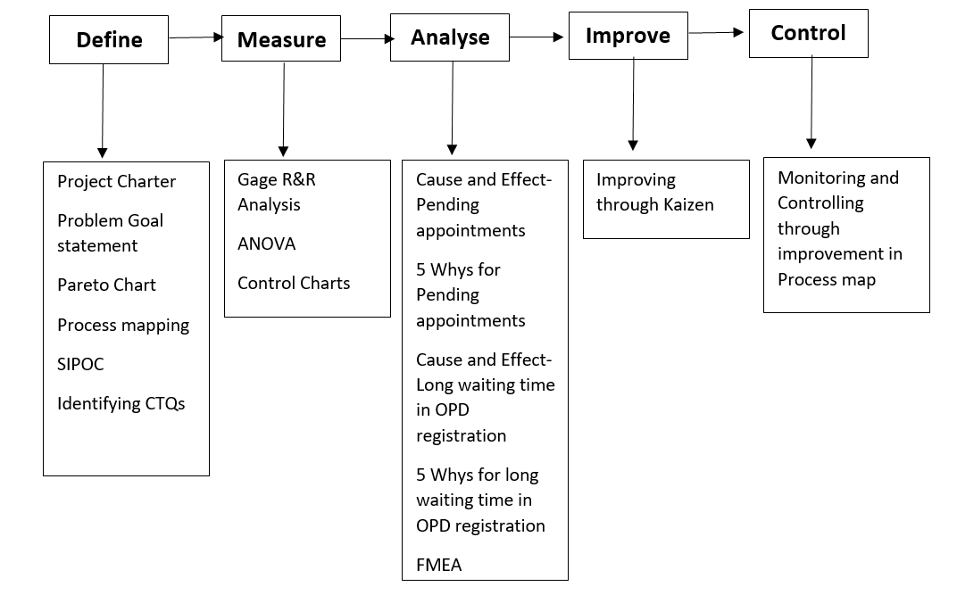

**IMPORTANCE OF DMAIC**

DMAIC consists of 5 phases: Define Measure, Analyze, Improve and Control. This approach is used in six sigma projects to solve quality related problems, and as a result improving the quality of products/ services. We have used this method in this project to detect and remove the causes of defects that result in long waiting time for patients in hospitals. This methodology was applied in order to emphasize quantifiable measures like DPMO and the Statistical and Analytical tools such as Pareto chart, Gage R&R and control charts. These tools have helped us to find the defects and suggest the measures to improve the customer service and hence improve the sigma level.

1. **Define Phase**

In the define phase, we have identified the critical issues currently facing by the patients due to the waiting period. We have gathered and identified the user requirements and key issues based on the control charts such as Pareto chart and project mapping process. Following are the various methods used to define the issues which occur in hospital due to wide range of waiting period:

* Project Charter
* Problem Goal Statement
* Pareto chart
* Process mapping
* SIPOC
* Identifying CTQs

1. **Project Charter**

**Project Start date:** Jan 9, 2018

**Project End Date:** Apr 10, 2018

**Financial Information:**

The estimated budget allocation is $100,000. This cost includes the planning and actual implementation for our technique in the health industry to improve the waiting time. We are expecting a profit of $20,000 by implementing our project.

**Project Manager:** Shalini

**Project Justification:**

Our plan is to implement the quality technique such as DMAIC and improve the sigma level at which the current service system in hospitals is.

**Project Objective:**

The purpose is to improve the sigma level for the hospital and improve the sigma level using DMAIC techniques to improve the waiting time for patients in the hospital.

**1.2 Problem Goal Statement**

The objective is to improve the sigma level at which the current service systemin the hospital works. We will be improving the sigma level using the DMAIC techniques to improve the waiting time for patients in the Hospitals.

* 1. **Pareto Chart**

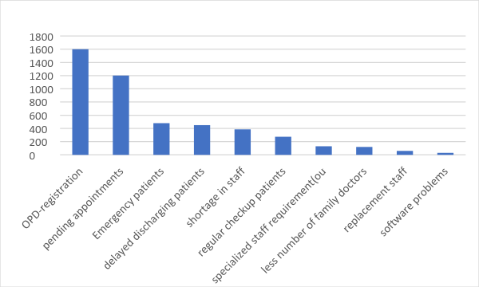

* 1. **Process Mapping**

Process planning is a flow chart representation of what the business does by keeping the roles and responsibilities in account. It represents the involvement of human and their respective activities.

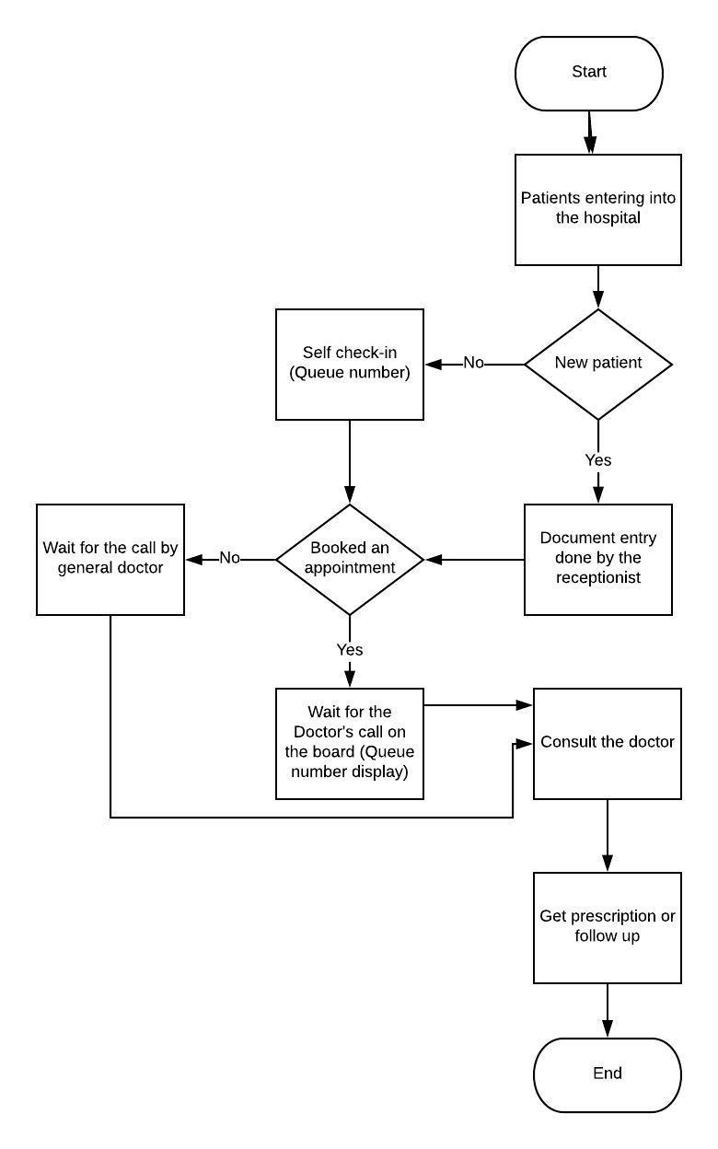

* 1. **SIPOC**

Check-In process for patients in a hospital

To obtain a better idea of the types of processes involved in the hospital management system, a process mapping initiative was undertaken. SIPOC represents higher level identification of the current state process in order to identify the major process elements. The SIPOC (Supplier, Inputs, Process, Outputs and Customer) methodology was chosen to best represent the user and activity flow of certain functions.

Suppliers: internal/external suppliers for the process.

Inputs: inputs to the process like material, forms, information, etc.

Process: entire process representation.

Outputs: outputs to internal/external customers.

Customers: internal/external customers to the process.

The first step is to identify the key steps within the process by listing 5-7 process elements. Then, other areas are listed associated with the project’s SIPOC. Further breakdown of sub-processes can be achieved later within this project. The diagram below demonstrates the SIPOC flow and illustrates the sequence of events and process outputs and the customers of those outputs so that the voice of the customer can be captured.

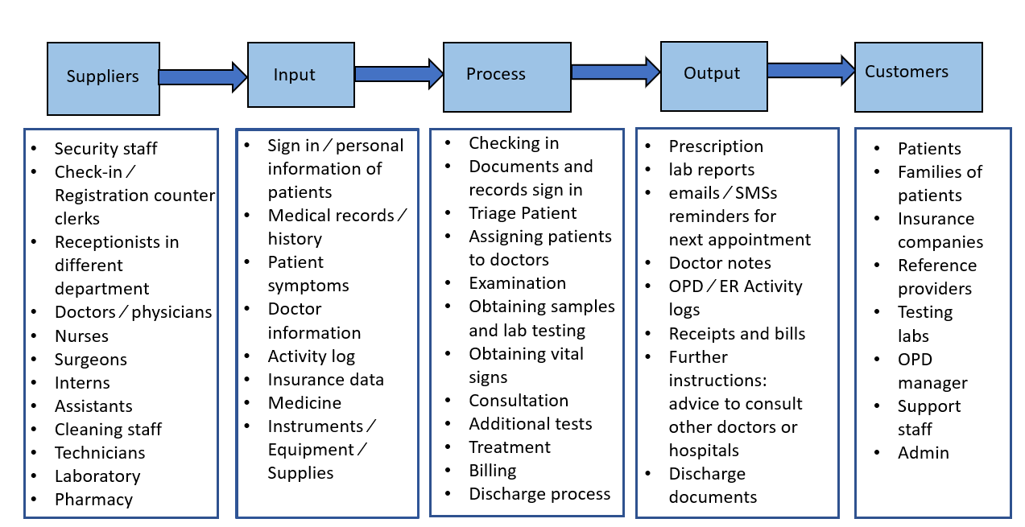

* 1. **Identifying CTQs**

Below are the current critical to quality parameters:

1. Efficient software implementation for self-check in.
2. Sufficient space for *Check in* process.
3. Online tool initiation to help residents get a family doctor.
4. Create ‘Super clinic’ which can be opened by either hospitals or doctors or medical professionals to improve doctor access for those who do not have family doctors.
5. Waiting time due to the delay in discharging patients to be reduced.
6. Number of doctors (Supply) and number of patients (Demand) at any time should be directly proportional.
7. Each doctor should have an assistant to help to follow up with pending appointments.
8. When a doctor is on vacation, the hospital should have enough backup to handle the pending appointments.
9. Each department should have enough medically trained professionals to perform small but necessary procedures before the patient meets with the doctor.
10. Scheduling regular check-ups in the less frequent times like in early mornings and late evenings.

**Defect Definition:** In our project, the defect includes any abnormal functioning of the above attributes thatcontribute to the overall success of the process. For example: If there is sudden rush in the usually less frequent hours, the whole dynamics of the waiting time regulation system of the hospital will be significantly disturbed. This will result in reduction of overall sigma level at which the process operates.

**Units:** Units is anything that can help us measure an attribute. For example in case of ‘Self-check in’counters the unit could be the counters. Another example could be sufficient number of doctors and nurses. Here members could be treated as a unit. So in this project, different attributes comprise of different units. The overall sigma level of such a process is composed of several processes working together to provide an overall success.

**Opportunities:** In our project we will consider the number of patients attending a hospital in Quebec for aparticular period of time. We will take into consideration a time period of 2 months over which such opportunities are considered. Each patient visiting the hospital in this period will be considered an opportunity.

Current Sigma Level: 1.6

Target Sigma Level: 3.4

1. **Measure Phase**

In this phase, we have identified the key issues faced by the patients and will measure the current performance of the waiting period system. We would be doing the R&R analysis and Capability Index study. We will determine the defects whether it is due to the time management or the shortage of resources. With the test data obtained from the previous months are generated using the control chart and after analyzing the chart we can conclude if the process is out of control or not.

**2.1 R&R Analysis**

The two major issues that we found in our project were

1. Long waiting period for the opd patients
2. Long pending appointments

The above issues can be caused due to various reasons like fewer doctors, unavailability of diagnosing equipments, waiting for prescribed tests and following opinion sheets.

We wanted to check among these issues which affected more on the waiting hours of patients. We considered to 20 patients minimum per hour coming in for the treatments. We have considered 3 trials and 3 operators to identify what affects mostly on the waiting period.

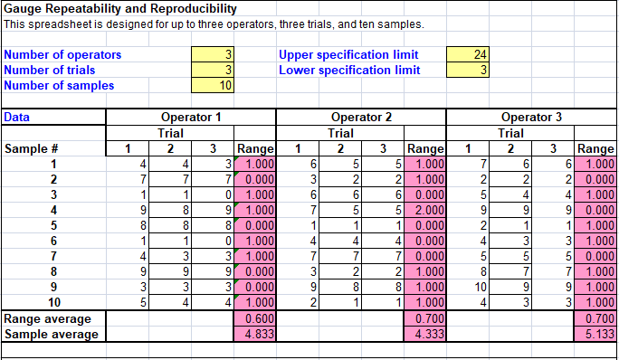

**2.2 Gage R&R Summary**

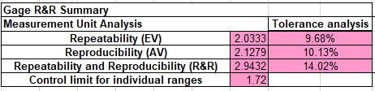

**2.3 Process Capability**

Process capability analysis (PCA) is performed to determine whether a process is capable of meeting certain requirements.

The Process Capability Analysis was done by logging in and noting the patient wait times. All figures are in minutes with a wait time operational definition of the patient entering the OPD facility until brought into a room to consult physician.

|  |  |
| --- | --- |
| Patient number | Waiting time in minutes |
| 1 | 44 |
| 2 | 27 |
| 3 | 28 |
| 4 | 48 |
| 5 | 47 |
| 6 | 48 |
| 7 | 47 |
| 8 | 28 |
| 9 | 54 |
| 10 | 42 |
| 11 | 21 |
| 12 | 67 |
| 13 | 37 |
| 14 | 52 |
| 15 | 38 |
| 16 | 37 |
| 17 | 27 |
| 18 | 29 |
| 19 | 40 |
| 20 | 27 |
| 21 | 36 |
| 22 | 42 |
| 23 | 33 |
| 24 | 43 |
| 25 | 38 |
| 26 | 57 |
| 27 | 37 |
| 28 | 37 |
| 29 | 45 |
| 30 | 41 |
| 31 | 38 |

Note: All values are rounded to the nearest minute for simplification purpose.

From the above observations, the following results are provided:

Average wait time: 39.83870 minutes

Standard Deviation: 10.05

Range of Expected Variation:

Lowest Point: 3

High Point: 24

Process Capability Index (Cp) = (UCL-LCL) ∕6σ = .3482

Cpu = (UCL-μ) ∕3σ = -0.525

Cpl = (μ-LCL) ∕3σ = 1.221

Cpk=min (Cpl, Cpu) = -0.525

Where UCL = Upper control limit, LCL = Lower control limit, σ = Standard Deviation and μ = Mean of the process

From the data and Cp computation, it is found that Cpk < 1 which indicates that the process is not stable. When Cpk is negative it means that a process will produce output that is outside the customer specification limits.

* 1. **ANOVA Gage R&R**

We have used ANOVA analysis to find out the differences among group means. It measures the variability amount of the whole system and compares the total variability observed to identify the viability of the system. We have used ANOVA one way and considered 3 trials with 3 operators. Each trial is analyzed separately using the ANOVA method by considering the LCL and UCL. The below data of patients minimum entering the hospital are considered.

For the first set of trial data

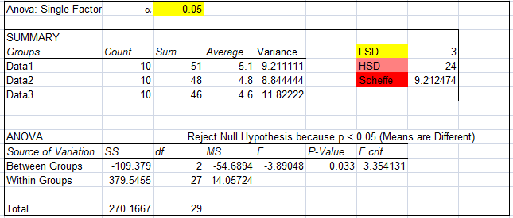

For the second set of trial data

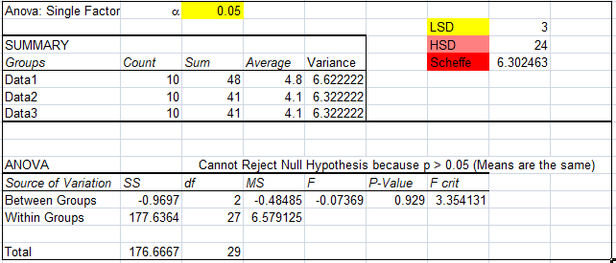

For the third set of trial data

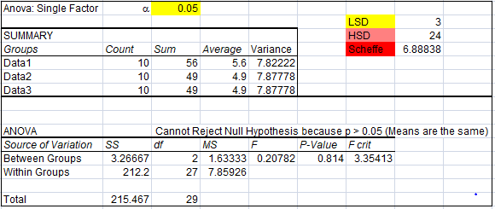

**2.5 Control Chart**

XbarR chart 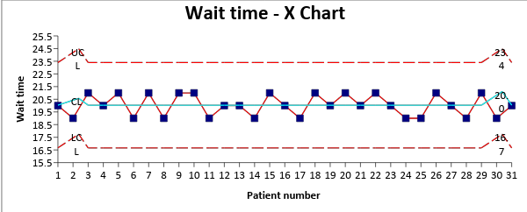

mR chart

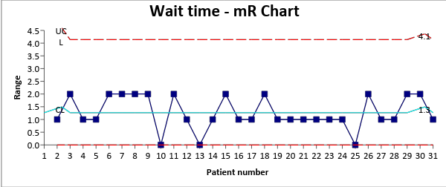

1. **Analyze Phase**

In this phase, we will be using the Cause and Effect diagram to analyze on the current issues. This approach will help us identify the key factors and the root causes that could effect because of those factors. Also, along with this approach we will be using the root cause analysis that would tell us the potential errors, its severity and recommended controls to be taken to improve the overall quality of the system.

* 1. **Cause and Effect Diagram – Pending Appointments**

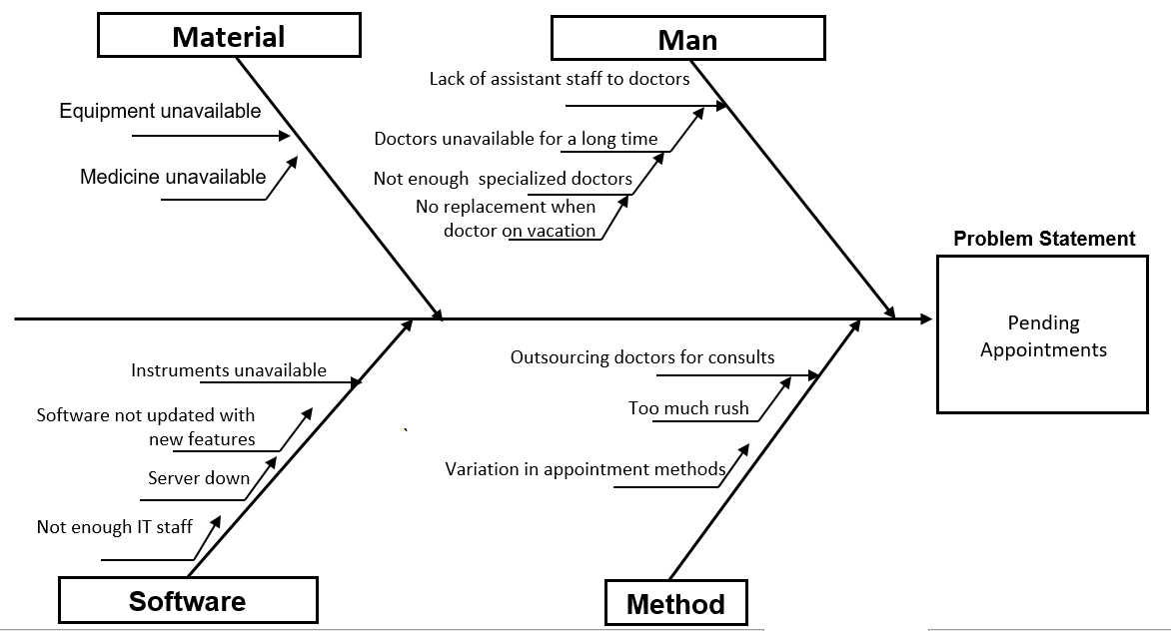

5-Why Analysis

Below are the reasons which led to more pending appointments. The basic issues leading to pedning appointments are based on less availability of doctors and therefore no follow ups are done.

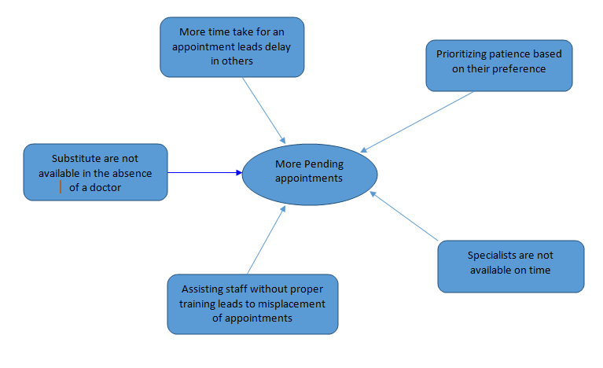

* 1. **Cause and Effect Diagram – Long Waiting time in OPD registration**

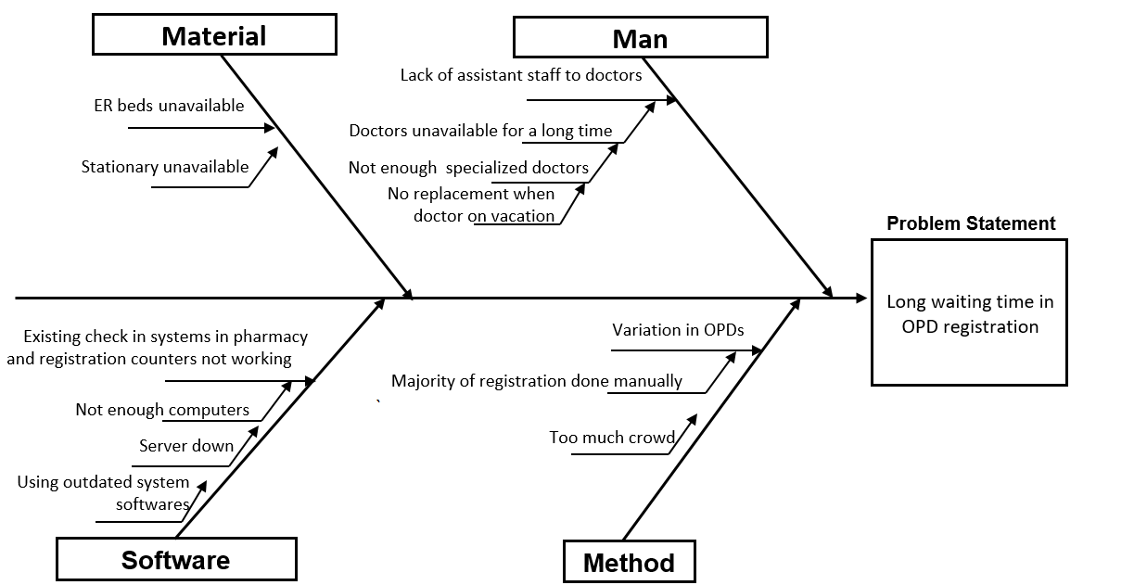

5- Why Analysis

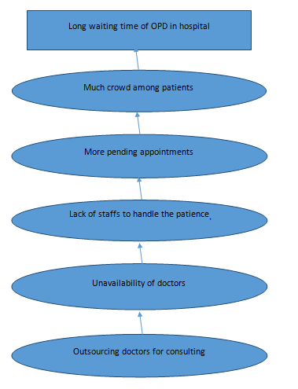

* 1. **FMEA**

FMEA stands for failure mode and effects analysis which is the systematic approach to identify and prevent the problems related to product and process before they actually occur.

**Objectives of using fmea**

* To make the system more robust
* To make the system fault tolerant
* Approach aimed at prevention of any sort of tragedy

**Who uses FMEA**

Engineers worldwide in different domains like aviation, nuclear power, aerospace, chemical process industries and automotive industries

**Rationales of FMEA**

Accidental prevention is the main reason of FMEA

Hospitals systems are not designed to absorb or prevent errors, they just reactively change and were not typically proactive

Identify and prioritize high-risk processes

**Criteria for FMEA**

A prospective assessment that identifies and improves step in a process thereby ensuring a safe and clinically desirable outcome

**Reasons model for Hospital Accidents**

The reasons for hospital accidents are found as follows

* lack of procedures
* punitive policies
* clumsy technology
* production pressures
* zero fault tolerance

**Steps or process of FMEA**

* Define the topic
* Assemble the team
* Graphically design the process
* Conduct the analysis
* Identify Actions and outcomes measures

**Step 1: Define the topic:**

Define the scope of Hospital failure mode and effects analysis along with clear definition of the process to be studied

**Step 2: Assemble the team:**

Assemble the team with the experts on subject matter plus advisor.

**Step-3: Graphically Describe the Process:**

This step involves developing and verify flow diagram with clear distinction of numbering of each process step identified in process flow diagram

**Step-4: Conduct a Hazard Analysis**

      This step involves listing of all failure modes with their causes along with their severity and probability.

**Step-5: Actions and Outcome Measures**

Involves decision of "eliminate”,” control" or "accept" the failure mode causes.

Below are the FMEA for all the critical issues found during the waiting period in the hospital.

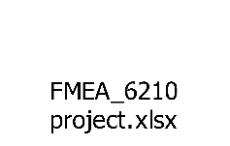

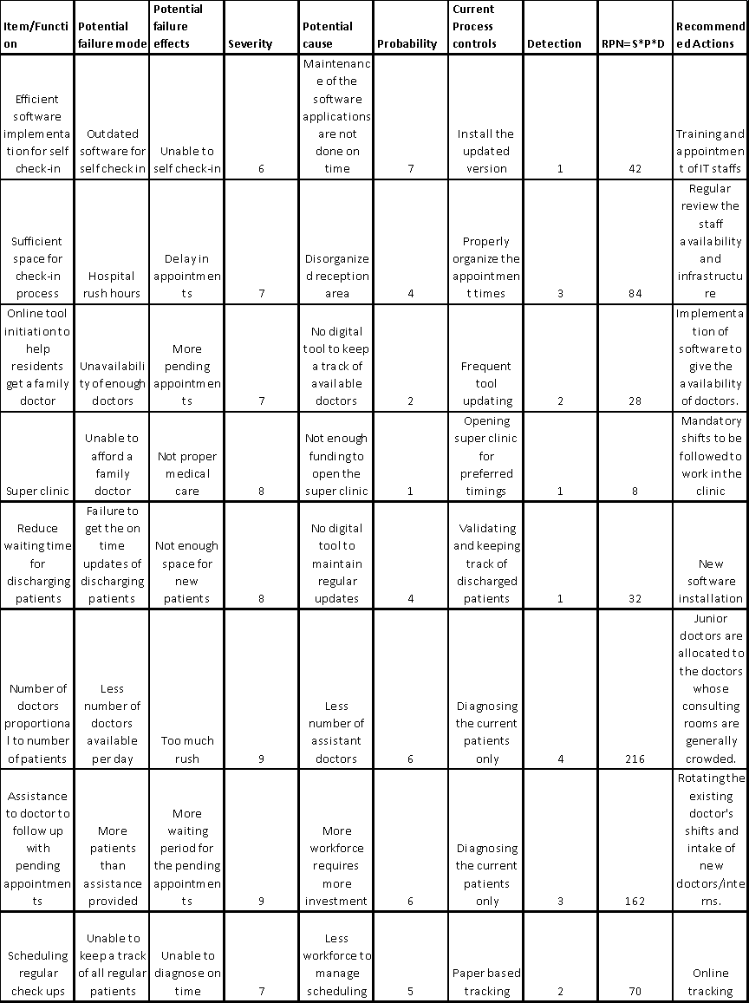

1. **Improve Analysis**

In this phase, after brainstorming the affected factors we will apply the results of analysis phase and create a temporary design change. With the help of data shown in the control chart, we can identify which factor has higher effect so that we can use the control measures to better the performance level. The higher the sigma level, the better will be the performance of the system.

* 1. **Brain Storming**

By using the Pareto chart we found the two major causes for the low DPMO rate as the following:

1. Long waiting time in OPD registration.
2. Pending appointments.

We conducted a brainstorming session and came up with multiple solutions to solve these problems.

The first problem is majorly to do with the poor management in the OPD registration area. However, the management is affected by several factors. We have analysed the whole management and found the major problems which we listed in the analysis phase. The second major problem is the pending appointments. The main cause for this is to do with the poor management of the staff.

The factors that were taken into consideration in this phase are:

1. The cost for the project: Since our major concern was the general hospitals rather than the private ones, the cost should be within the budget released for the improvement of the hospitals in the Quebec area.
2. Simplicity and feasibility: The solutions must not disrupt the regular function of the hospital, so we tried to propose solutions which can be implemented without changing much of the internal structure and are feasible.
3. CTQs: The CTQs (Critical to Quality characteristics) are the major foundation of the project. The assessment of these characteristics was carefully done during our brainstorming sessions to improve the service quality of Quebec hospitals.

* 1. Improvement through Kaizen

Improvement phase for Pending appointments

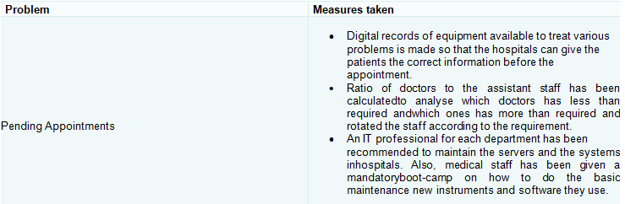

Below are the effects:

* DPPM trend improved
* Effect of pending appointments in the long waiting time has been reduced.

Improvement phase for waiting time in OPD registration

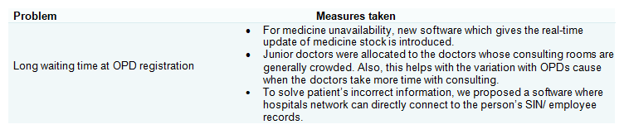

Below are the effects:

* DPPM trend improved
* Organized medicine stocks made pharmacy management very efficient.
* Waiting time improved in Outpatient department in the hospitals.
  1. **Improved Process Capability**

This approach has been recommended for improvement considering variables that impact wait times. The project team brainstormed five possible reasons for the delay as:

1. Staff size
2. Order of treatment
3. Treatment method
4. Tracking software
5. Waiting room temperature

The factors or each experiment can be listed as:

|  |  |  |  |
| --- | --- | --- | --- |
|  |  | Level (-) | Level (+) |
| A | Staff Size | 8 | 16 |
| B | Order of Treatment | FIFO | By Priority |
| C | Treatment Method | Iterative | All at Once |
| D | Tracking Software | Product A | Product B |
| E | Waiting Room Temp | 68 Degrees | 1. degrees |

* We found an inadequacy in the check-in procedure and came up with a simple solution by eliminating a step in the check-in process that could be implemented without disrupting staffing limitations or violating union contracts. Before Six Sigma was implemented patients would sign in and the medical assistants would process their charts. These charts would then be given to back-clinic medical assistants to bring patients to examination rooms. The reception staff will be interrupted by phone calls, patient walk-ins and other duties which delayed this process. This problem was corrected by separating check-in and reception clerks. The check-in clerk was moved to the back-clinic area to bring patients to examination rooms.
* There also was a delay in the time for check-in clerks to bring the patient back to the exam room in most cases, this delay was due lack of available exam rooms. This was solved by an order board posted in a common area to prevent delays in patients waiting for procedures such as injections. Also, whether the examination rooms were occupied or free was made available online (software), so that it was easy for check-in clerk to get to know which room is available for next patient.
* Making adjustment to room temperature setting to a more comfortable setting made a significant impact for a reduction in wait times.
* Average wait time has decreased slightly using another product which began prioritizing patients as this has reduced the average wait time.
* Software identified some patients as first-time visitors and some of the patients as return visitors. The project team changed the process so that first-time visitors were processed ahead of time; thus, reducing their wait time this decreased the overall average wait time.

|  |  |
| --- | --- |
| 1. Problems | Solutions |
| Lengthy Queue for registration | Start Multiple Registration Counters |
| Registration form is lengthy & difficult to fill | Simplify Registration Form |
| Lack of proper communication | Provide adequate training for staff |
| Time taken to barcode & process the samples in lab/ blood reports takes more time | Provide a dedicated machine test in OPD |
| Asking patients to report at the same time at OPD | Segregated appointment to be given based on the fasting blood sugar need and the appointments available as forenoon and afternoon |

All the above solutions were implemented, and results were observed. Data were collected to study and observe the level of improvements.

Wait time after applying six sigma techniques:

|  |  |
| --- | --- |
| Patient number | Waiting time in minutes |
| 1 | 20 |
| 2 | 19 |
| 3 | 21 |
| 4 | 20 |
| 5 | 21 |
| 6 | 19 |
| 7 | 21 |
| 8 | 19 |
| 9 | 21 |
| 10 | 21 |
| 11 | 19 |
| 12 | 20 |
| 13 | 20 |
| 14 | 19 |
| 15 | 21 |
| 16 | 20 |
| 17 | 19 |
| 18 | 21 |
| 19 | 20 |
| 20 | 21 |
| 21 | 20 |
| 22 | 21 |
| 23 | 20 |
| 24 | 19 |
| 25 | 19 |
| 26 | 21 |
| 27 | 20 |
| 28 | 19 |
| 29 | 21 |
| 30 | 19 |
| 31 | 20 |

From the above observations, the following results are provided:

Average wait time: 20.03 minutes

Standard Deviation: **0.836**

Range of Expected Variation:

Lowest Point: 3

High Point: 24

Process Capability Index (Cp) = (UCL-LCL) ∕6σ = 2.2857

Cpu = (UCL-μ) ∕3σ = 1.5829

Cpl = (μ-LCL) ∕3σ = 6.790

Cpk=min (Cpl, Cpu) = 1.5829

Where UCL = Upper control limit, LCL = Lower control limit, σ = Standard Deviation and μ = Mean of the process

From the data and Cp computation, it is found that Cpk ≥ 1.33 which indicates that the process is highly capable.

Process Capability Analysis (PCA) shows that the observed average waiting time was estimated to be 20.03 minutes with a standard deviation of 0.836 minutes (a significant reduction in average and standard deviation). A dot plot was prepared to compare the waiting times before and after the study.

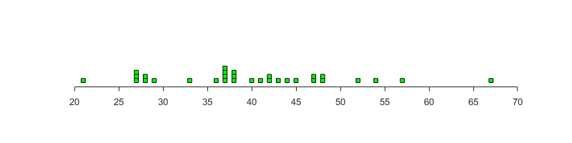

Dot plot before Six Sigma

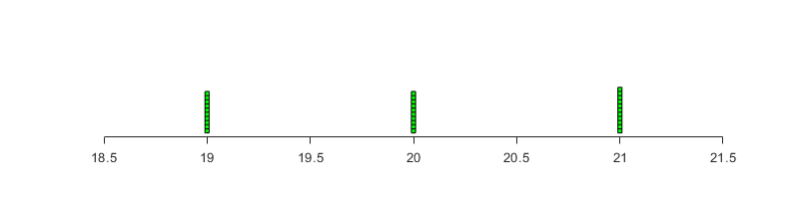

Dot plot after implementing Six Sigma

1. **Control Phase**

In control phase, we will be monitoring the system in which we made changes by tracking the key performance factors and CTQ’s. By monitoring and controlling we can assure that the system implemented is working as per plan.

* 1. **Revamping Existing Process**

The major improvement on the existing phase was done. The improvement made in these phases was analyzed by keeping track on the key performance and CTQ’s.

* Head of department was made to monitor staff allocation and staff holiday approval on weekly basis.
* Checking in time for patients was recorded and run chart was plotted to monitor the patient waiting time. A prepared sample run chart is given in the Figure.

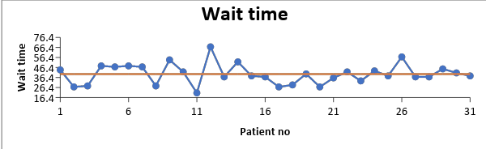

This chart shows a similar pattern to that of the chart in above Figure, but with less variability.

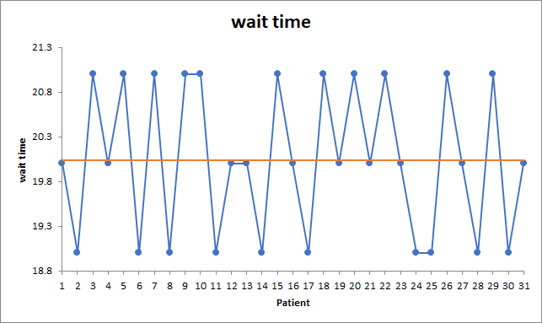

* Also, Guidelines were provided to the employees and improvements were recorded.
* All the recorded data from monthly report was used to generate control chart. These control charts determine the performance of process with in specified control limits.
* Comparison of results to form a basis of corrective action was done.
* The employees were trained to observe and discover the most critical defects and the ways to improve their performance.
* A backup plan was prepared in case the variability observed in the process is high. The training session to employees helped them better identify the causes. This plan explains about the possible actions to be taken when the run chart shows any signals of more variation in the process. Once a run chart was constructed for monitoring the waiting time of patients, the responsibility of preparing the chart daily was given to the clerks in the opd. This plan was prepared by keeping in mind that the persons monitoring the process may not be always aware of Six Sigma and various improvement initiatives to act on the process.
* A detailed manual describing these procedures and steps were also prepared. The purpose of this manual was to serve as a quick guide to new employees to the company.

The average and standard deviation of data was calculated every month and reviewed at departmental meetings.

Data from the process was collected and analyzed and conclusions were made. Because of this project, the waiting time reduced from 39.83minutes to 20.03 minutes.

* 1. **Improved Process Map- for Monitoring and Controlling**

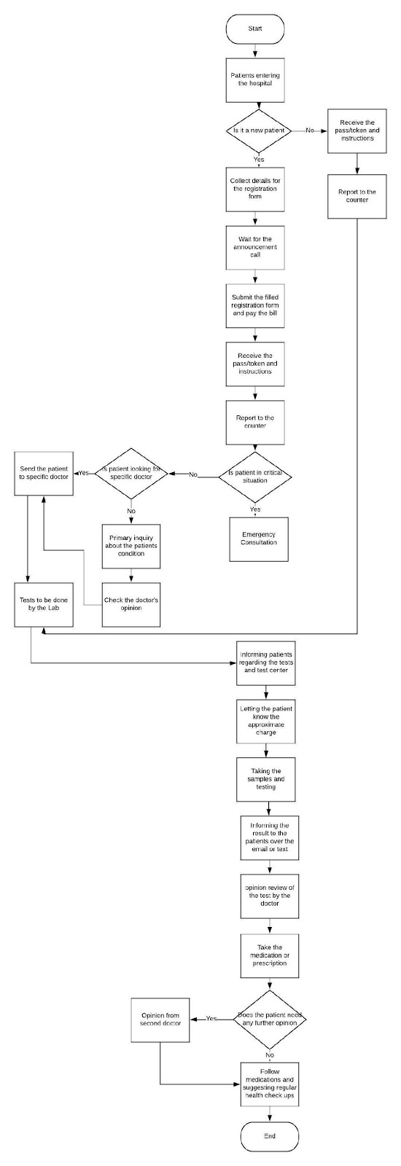

* 1. **Survey**

      A survey in which the patients and families of patients were selected as sample groups to capture their ideas then the feedback regarding the performance of the system was released.

The results were collected and analyzed for 31 observations to interpret and monitor the current situation and compare it with the targeted condition. We attempted to identify the problems faced by the users on a regular basis. Some of the resulting data from the survey is real and some is estimated because the information and data were not available.

Based on information provided by those who entered the hospital, the following reasons were given for dissatisfaction:

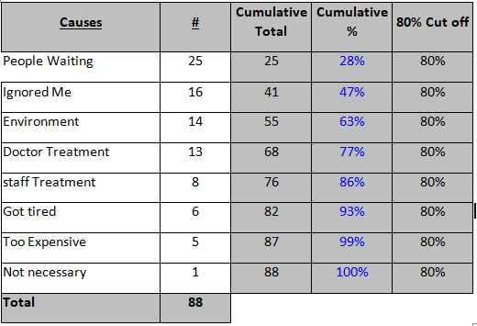

From the above data, the project team decided to focus on the first six reasons.

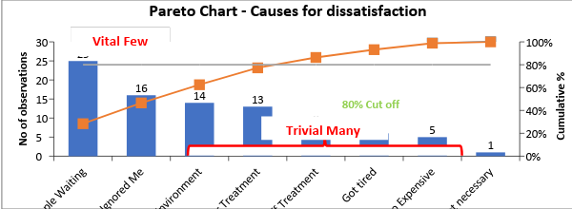

1. **Conclusion**

We have taken the data recorded for number of patience visited a hospital and number of people missed the appointment because of long waiting time.

Total number of opportunities: 3146

Total number of defects: 1412

DPMO: 448824

Sigma level: 1.63

After:

Total number of opportunities: 2914

Total number of defects: 81

DPMO: 27797

Sigma level: 3.41

1. **References**

<https://www.mtlblog.com/news/quebec-emergency-room-wait-times>

<http://www.ihi.org/resources/Pages/ImprovementStories/ShorteningWaitingTimesSixPrinciplesforImprovedAccess.aspx>

<https://globalnews.ca/news/3084366/q-a-how-long-are-medical-wait-times-in-canada-by-province-and-procedure/>

<https://onlinelibrary.wiley.com/doi/full/10.1002/qre.1552>